Holiday plans (Планы на каникулы)
Гульнара ХАЕРНАСОВА,
учитель английского языка первой квалификационной категории средней школы №77 г. Казани
Эльза САГИТОВА,
учитель английского языка первой квалификационной категории средней школы №77 г. Казани
Цели урока:
- Практическая и образовательная: совершенствовать лексико-грамматические навыки говорения (активизировать лексику по теме «Выходной день», создать условия для формирования грамматических навыков по теме грамматический оборот «To be going to..»).
- Развивающая: развитие мышления, памяти, логики, формирование навыкв общения
- Воспитательная. Воспитание культуры мышления, общения и поведения на английском языке. Формирование потребности использовать речь, адекватную ситуации общения.
Задачи урока:
- Обобщить лексический и грамматический материал, изученный по данной теме.
- Совершенствовать и контролировать умения и навыки практического владения английским языком по данной теме по всем видам речевой деятельности: аудированию, говорению, чтению и письму.
- совершенствовать грамматические навыки говорения (to be going to do smth.).
- стимулировать желание учащихся высказываться на английском языке.
Тип урока: Урок-закрепление
Методы: Активные методы обучения, метод проектов ,элементы сингапурской методики.
Оснащение: доска, монитор, лексические карточки с активной лексикой, презентация по данной теме, рисунки, фотографии, грамматические таблицы с оборотом «to be going to do smth».календарь.
Ход урока:
I.Орг. момент T: Good morning, boys and girls. I`m glad to see you. Let’s start our lesson. Look at the first slide. Oh, what happened? Children unfortunately, we can’t start our lesson. There is a lock. What shall we do? I think that we must find the right keys for the lesson. I think we must try to guess what our lesson will be about.
Let’ try to do it. I’ll do my best to help you. There are some pictures on your desks. Your home task was to learn new words. Now let’s check your home task. Look at the pictures and label the pictures using phrases.
T: well done. These words will help us during our lesson. Students. I’ve got a letter from our pen friend. Let’s read it.
Dear friends,
Hello. My name is Mark. I am 11. I live in London. I am very sporty active boy. But sometimes I like to play computer games, watch a good film or listen to music.
I am going to visit your city at the weekend. I’d like to know how do you spend your weekends.
Yours
Mark
T: Thank you very much. Let’s try to help him. Now look at the next slide and try to guess what we will speak about today? What can you see here?
S: Holidays. Weekends. Our activities…
T: Yes, you are quite right. Today we are going to learn how to speak about our plans for the weekend. It is very important to have a good rest because it helps us to work and study well. I hope you will work well and everybody will get an excellent mark. Look, we can open our lock. And we can continue our lesson.
II. Актуализация опорных знаний.
Students. Let’s remember the grammar structure to be going to? We will practice it today. Do you remember all the forms of the verb to be? There are some puzzle-cards on your desks. Find them. You have to match them. You have got 1 minute. I want you to work in small groups.(Активный метод обучения «Пазл»,использую карточки-пазлы.)
Now let’s check .And put them on the blackboard. (I am, He is, she is, …..)
To be going to V
T:great. your home task was to take photos about your plans to the nearest holiday. I have mixed them. Take photo and make up sentences using this photo and our active grammar structure.
e/g I am going to hang out with my friends. Dinara is going to cook……
T: Well done. And now ask questions to your classmates using this grammar.
e/g Sabina, are you going to visit your relatives?
Аудирование.
T: Well done. Now we are going to continue! There are some pictures on your desks. Look at these pictures! Listen to me. I will tell you about my plans to the nearest weekend. If I am not going to do it, cross the picture!
Учащиеся зачеркивают только картинки, которые не соответствуют планам учителя. По окончании учащиеся отвечают на вопрос What I am not going to do? –
This weekend is my daughter’s birthday. We are going to arrange a funny party. We will cook a big, tasty cake. My daughter’s friends will dance, listen to music. Children are going to play very interesting table game. We are going to take photos. We will spend a great time. (Картинки)
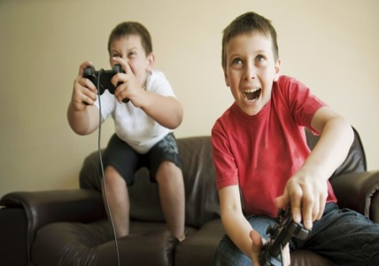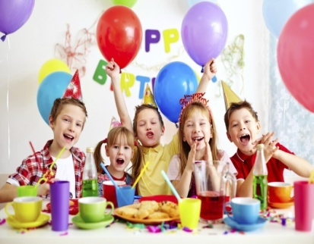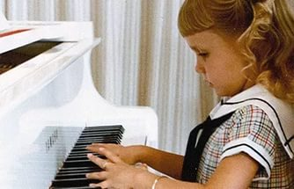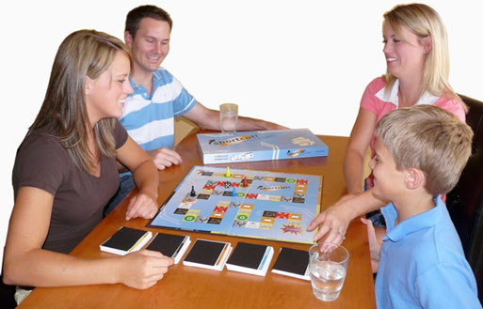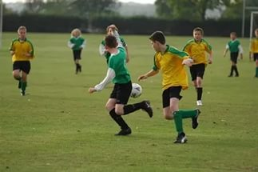
T: Now let’s check. Make up negative sentences using these pictures. Well done.
Динамическая пауза.
I think that you are tired and want to have a rest. By the way, do you like to listen to music? Now, we will listen to the song and have a rest. Listen to it carefully. And try to understand what they are going to do. (прослушивание песни “ Let’s go to Funland.” стр145)128
T: Do you like the song? Have you understood it? Now find cards with some sententeses. Now we will read sentences. Are these sentences true or false?
- They are going to visit London. F
- They are going to eat hot dogs and ice cream. T
- They are going to play hockey. F
- They are going to have a picnic and sit in the park. T
- They are going to take a lot of photos. T
- They are going to go to the castle. T
T: well done.
Грамматика. Лексика.
Now let’s continue. Look at your desks. There is an envelope in your table. You can find cards with words. Put the words into the correct order to make questions about next weekend. You have got one minute. Work in small group.(Активный метод обучения «Паравозик»
- Are you going to hang out with your friends?
- Are you going to watch a film?
- Are you going to play the whole day?
T: Now let’s check your sentences. Ask them to your classmates.
T: Well done. I know that you like to play games. Would you like to play
Tic-tac-toe. Well, you have got shit of papers with words. Your task is to make as many sentences as you can.(Элемент Сингапурской методики)
The girl | To play tennis | To arrange funny party
she | Is, am,are | To plant flowers
I | we | To visit her grandmother

Говорение. Письмо.
Group work.
T: great job. Let’s continue our work. Now we will work in groups. We have got three project- posters and 3 groups. 1-about Kazan, 2-about London, 3-about Moscow. You can see some pictures. Make up as many sentences as you can about plans for weekend. Don’t forget to use grammar structure to be going to… .You have got 3 minutes.
T: well done. Let’s go on.Do you remember our new words? On your desks you have got stickers. Write 3 things you are going to do next week.
e/g help parent, read a book, do shopping…..
Now choose your list with your partners. Read your partners words. And answer the question what are your classmates going to do next weekend. e.g my friend is going to read a book.
T: Well done. Look at the next slide. You can see here two friends. They are going to have a sleepover tonight. What are they going to do? Make sentences with going to and these words.
Watch eat drink listen play phone take

Sweets cola their friends a computer game A film
some photos to music

T: good. Now let’s listen and check your answers.
T: Students. Your home task will be to write a letter to your pen friend about your plans to the next weekends. Don’t forget to use our active grammar and new words.
Now I want you to look at the blackboard. We will continue our lesson with small project. We can see a calendar. I ask you to write your plans to the nearest
Weekends and stick them to the right date.
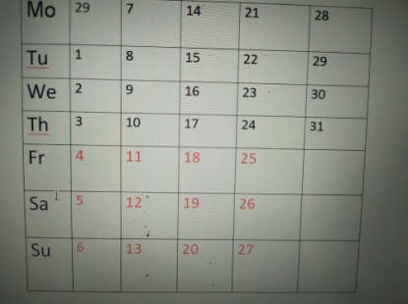
Well done. I prepared one more task for you. Now students you have got some tickets. These tickets are unusual. You should rewrite your sentences using all material.
Write your name and it will be your TICKET TO LEAVE.
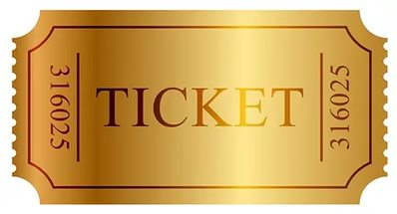 | - She…. going to play a lot of sport.  - … you going to surf the Internet.  - They …. Not going to ….. to music.  - Eivina …going to hang … with her friends.  - We are not … to get up late.
Итог урока. Домашнее задание.
T: Your homework will be to write a letter to your pen friend about your plans to the nearest weekends.
Thank you very much for your job. I hope you will spend very interesting weekends. Don’t forget to take interesting photos. Good buy .I wish you good luck.
Список использованной литературы.
- Активные методы обучения: рекомендации по разработке и применению: учеб.-метод. пособие / Зарукина Е.В., Логинова Н.А., Новик М.М. – СПб.: СПбГИЭУ, 2010. – 59 с.
- Кругликов В.Н., Платонов Е.В., Шаранов Ю.А.
Деловые игры и другие методы активизации познавательной деятельности. – СПб.: П-2, 2006. – 190 с.

