Смотр знаний по английскому языку

(VI класс )

**Флюра ИБРАГИМОВА, Лилиана ХАМИТОВА,**

*учителя английского языка гимназии №10 г Зеленодольска*

**Цели урока:**

*образовательная:* обобщить и систематизировать знания по теме: «Дом, милый дом», активизировать практическое применение языка на основе полученных знаний;

*развивающая:* способствовать развитию навыков поисковой деятельности, мышления, догадки, расширить эрудицию учащихся;

*воспитательная:* воспитание в учащихся семейных ценностей, уважительного отношения к труду в доме, оказание помощи родителям по дому, толерантного отношения друг к другу, умения работать к группах, поддерживать, сопереживать друг другу, командный дух.

**Lesson procedure. Ход урока**

1. Introduction. Введение

Good afternoon, children! I’m glad to see you. Sit down! We are going to have an unusual lesson today, the lesson-competition. The competition consists of several tasks. If you answer correct the team will get one point. You will get nothing if you answer wrong.

2. Look at the screen. What are we going to speak about?

You are right. We are going to speak about house.

3. So there are two words «home» and «house»

And there are translated into Russian as дом**.** What is the difference between them? Will tell us through the proverb?

Yes, Men make house, women make home.

4. T.: What is home for you, children, I wonder?And what do English children think about it? You will see in the text. Your task is to read and translate these opinions.



5. In order to have a warm house we need people. In our previous lessons we spoke about people, their appearance, clothes and characters. Your task is to remember the words connecting with these topics.

|  |  |  |  |  |
| --- | --- | --- | --- | --- |
|  | B | C | S | H |
| Appearance | body | curly | slim | hair |
| Clothes | boots | cap | shirt | hat |
| Character | bossy | clever | shy | honest |
| House | bed | curtains | sofa | heating |
| Adjectives | bad | cold | sad |  |

6. The game «**Hide and seek»** Виртуально прячем предмет в комнате

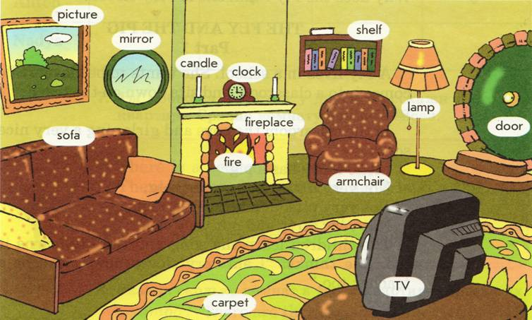

Is it in the middle of the room?

Is it in the wall unit?

Is it behind the sofa?

Is it under the armchair?

Is it between the windows?

Is it in the bookcase?

Is it in the corner?

Is it in the right corner?

7. And now we want you to remember all the objects in the picture. You have only **30** seconds for it. You should name all things what you have remembered, оборот there is there are

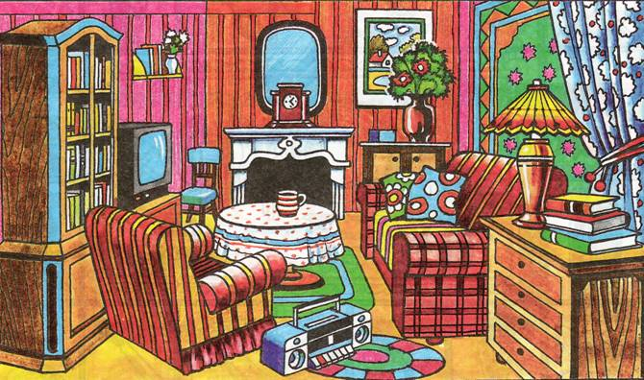

8. Учитель диктует предложения, учащиеся рисуют схему комнаты.

This is a room. There are two windows in the room. There is a door opposite the window. There is a fridge between the windows. It is white. There is an oval table in the middle of the room. There are 4 chairs near the table. There is an electric cooker near the wall. Next to the electric cooker there is a cupboard. There is a vase on the table. Opposite the table there is a sofa. There is a TV-set in the corner, next to the window. There are flowers on the windows. There is a colourful carpet on the floor. There is a cat on the sofa . there are curtains on the windows. There is a picture on the wall.

9. Well done. You can describe the picture very well. And now find the difference between two pictures

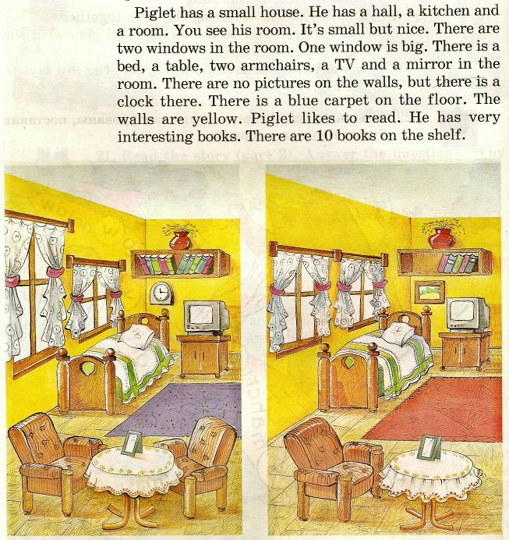

10. As you have understood all these things make our home, room cosy and comfortable and modern conveniences make our life easier.

What things make Piglet’s home comfortable you will see through «Running dictation».

Piglet has a small house. He has a hall, a kitchen and a room. It’s small but nice. There are two windows in the room. One window is big. There is a bed, a table, two armchairs, a TV and a mirror in the room. There are no pictures on the walls, but there is a clock there. There is a blue carpet on the floor. The walls are yellow. Piglet likes to read. He has very interesting books. There are 10 books on the shelf.

11. Home is the place we do many different things what we need and what we want . Match the words in the table.

12. Every living being has his own house.

There are many proverbs, poems about it. Let’s play a game: «Spy Code»

* 5-1-19-20 15-18 23-5-19-20 8-15-13-5 9-19 2-5-19-20
* 13-25 8-15-13-5 9-19 13-25 3-1-19-20-12-5
* 5-22-5-18-25 2-9-18-4 12-9-11-5-19 9-20-19 15-23-14 14-5-19-20
* 20-8-5-18-5 9-19 14-15 16-12-1-3-5 12-9-11-5 8-15-13-5
* 1. East or West, home is best.
* 2. My home is my castle.
* 3. Every bird likes its own nest.
* 4. There is no place like home

13. Home is the place we do many different things what we need and what we want. Here is more difficult task , What are they doing now? Who usually does these things in your family?

.

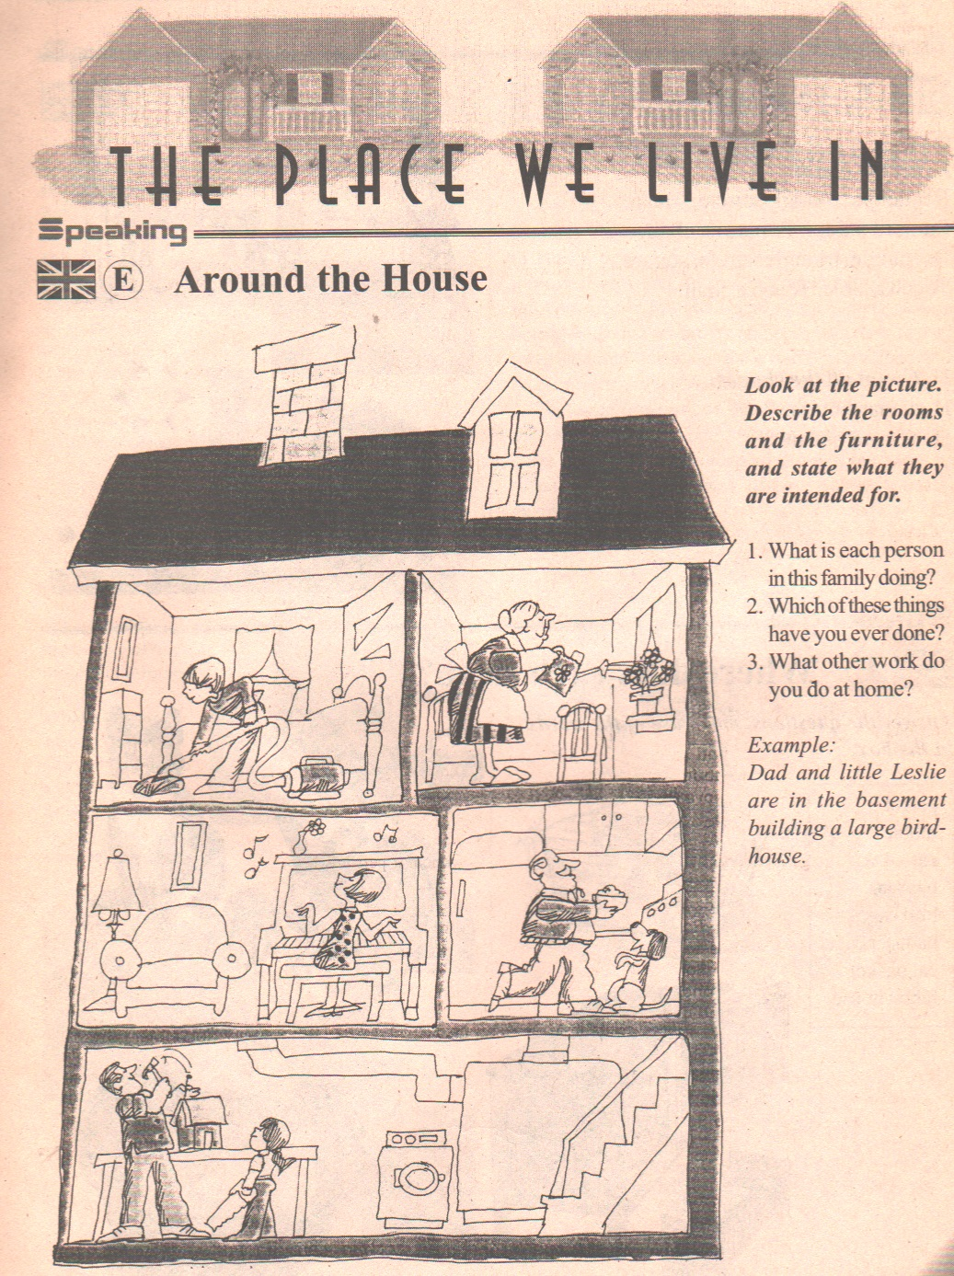

14.Houses can be different like caravan, tepee, lighthouse, houseboat.

They can be in different places in the mountains, on the beaches and in the forests like this one

Prediction.

In the dark dark wood   
There is a dark dark ....

In the dark dark house  
There is a dark dark ........

In the dark dark room

There is a dark dark ....

In the dark dark cupboard

There is a dark dark ....

In the dark dark shelf

There is a dark dark ....

In the dark dark box

There is a dark dark ....

In the dark dark surprise!

15. Thank you. Now tell me What have you done? What have you memorized? What have you learnt?